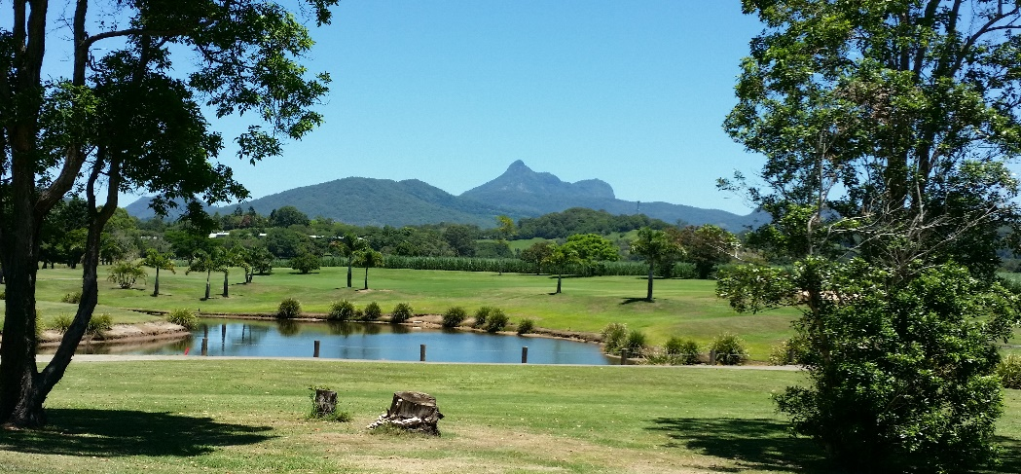
OPEN DAY 2024

WOMEN’S GOLF MURWILLUMBAH

Visitors’ Entry Form
Date: TUESDAY 28TH May 2024
Event: SINGLE STABLEFORD
Time: 7.00– 8.30am - 1st & 10th Tees
Raffle: IN AID OF BREAST CANCER – PLEASE WEAR PINK
Prizes: Great Division prizes; Nearest to the pins on all par 3’s; Longest drives; Ball run down
Entry Fee: $40 per player (includes comp and green fees and Morning tea)
*Cart hire must be arranged through Golf Shop (02) 66724200 ($23 per seat)
Lunch available from Lynn’s Cafe
Closing Date: Tuesday 14th May 2024
TYPE INTO THIS FORM
Name of Club: |  |  |  | Club Golflink Prefix:
Club Representative for this event:
 | Mobile: |  |  | Email:
Player | Golflink No. | GA Hcp | Paid  $40 | Cart booked  Yes or No | Sharing cart with
1.
2.
3.
4.
5.
6.
7.
8.
9
10.
Total Amount $
Entries will only be accepted if accompanied by payment - EFT/DIRECT DEPOSIT
Bank Details: Commonwealth Bank – BSB: 062580 A/C:28017021
Account Name: Womens Golf Murwillumbah
Please include reference of:
- MOD + your club - if Club payment
- MOD + your first initial and surname – if paying individually
Save this form and Email with copy of confirmation slip to: murbahwomensgolf@gmail.com
DRAW WILL BE POSTED ON OUR WEBSITE homepage www.murwillumbahgolfclub.com.au by the 21st May 2024

