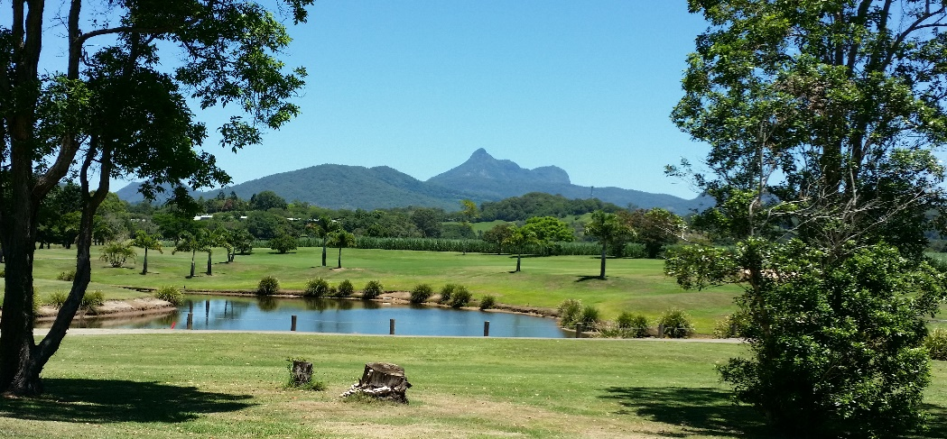
OPEN DAY 2024

WOMEN’S GOLF MURWILLUMBAH

MEMBER’S ENTRY FORM

Date: TUESDAY 28th May 2024
Event: SINGLE STABLEFORD
Cost: $13
Time: 7.00 am to 8:30 am – 1st & 10th tees
Raffle: IN AID OF BREAST CANCER – PLEASE WEAR PINK or CLUB SHIRT
Prizes: Great Division prizes; Nearest the pins on all par 3’s; Longest drives; Ball run down
*Cart Hire must be arranged through the Pro Shop
Closing Date: Tuesday 14th May 2024 Draw will be posted by 21st May 2024

 |  | Name |  | Need  Cart | Own  Cart |  | Walk |  | Sharing with & any other comments
 | Name |  |  | Need  Cart |  | Own  Cart | Walk | Sharing with & any other comments
 |  |  | Name | Need  Cart | Own  Cart |  | Walk |  | Sharing with & any other comments

