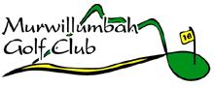
2023 Club Championship Results

WINNER SCORE
Club Champion Warren Colefax 309

Division 2 Winner Glen Cramb 337

Division 3 Winner Tim Whitney 375

Division 4 Winner Daryl Burgess 389

Overall Nett Winner Chris Brown 291

Division 2 Nett Winner Riley Lack 293

Division 3 Nett Winner Desmond James 305

Division 4 Nett Winner Matt Palmer 300 O.C.B

Senior Vet Winner Peter Tomsett 338

Junior Vet Winner Steven Graham 329

Junior Club Champion Harrison Wood Nett 70

